Lesson 2: The Multiplication of Polynomials

Student Outcomes
- Students develop the distributive property for application to polynomial multiplication. Students connect multiplication of polynomials with multiplication of multi-digit integers.

Lesson Notes
This lesson begins to address standards A-SSE.A.2 and A-APR.C.4 directly, and provides opportunities for students to practice MP.7 and MP.8. The work is scaffolded to allow students to discern patterns in repeated calculations, leading to some general polynomial identities that will be explored further in the remaining lessons of this module.
As in the last lesson, if students struggle with this lesson, they may need to review concepts covered in previous grades, such as:
- The connection between area properties and the distributive property: Grade 7, Module 6, Lesson 21.
- Introduction to the table method of multiplying polynomials: Algebra I, Module 1, Lesson 9.
- Multiplying polynomials (in the context of quadratics): Algebra I, Module 4, Lessons 1 and 2.
Since division is the inverse operation of multiplication, it is important to make sure that your students understand how to multiply polynomials before moving on to division of polynomials in Lesson 3 of this module. In Lesson 3, division is explored using the “reverse tabular method,” so it is important for students to work through the table diagrams in this lesson to prepare them for the upcoming work.
We continue to draw a sharp distinction in this curriculum between justification and proof, such as justifying the identity ${\left(a+b\right)}^{2}=a^{2}+2ab+b$ using area properties and proving the identity using the distributive property. The key point is that the area of a figure is always a nonnegative quantity, and so cannot be used to prove an algebraic identity where the letters can stand for negative numbers (there is no such thing as a geometric figure with negative area). This is one of many reasons that manipulatives such as Algebra Tiles need to be handled with extreme care: depictions of “negative area” actually teach incorrect mathematics. (A correct way to model expressions involving the subtraction of two positive quantities using an area model is depicted in the last problem of the Problem Set.)
The tabular diagram described in this lesson is purposely designed to “look like” an area model without actually being an area model. It is a convenient way to keep track of the use of the distributive property, which is a basic property of the number system and is assumed to be true for all real numbers—regardless of whether they are positive or negative, fractional or irrational.

Classwork
Opening Exercise (5 minutes)
The Opening Exercise is a simple use of an area model to justify why the distributive property works when multiplying $28 × 27$. When drawing the area model, remember that it really matters that the length of the side of the big square is about $2\frac{1}{2}$ times the length of the top side of the upper right rectangle ($20$ units versus $8$ units) in the picture below and similarly for the lengths going down the side of the large rectangle. It should be an accurate representation of the area of a rectangular region that measures $28$ units by $27$ units.
Opening Exercise
Show that $28×27=(20+8)(20+7)$ using an area model. What do the numbers you placed inside the four rectangular regions you drew represent?
$$20$$
$$8$$
$$7$$
$$20$$
$$140$$
$$400$$
$$56$$
$$160$$
$$28×27=\left(20+8\right)\left(20+7\right) \\ =400+140+160+56 \\ =756$$
Scaffolding:
For students above grade level, you might ask them to prove that $\left(a+b\right)\left(c+d\right)=ac+bc+ad+bd,$ where $a,b,c,$ and $d$ are all positive real numbers.
The numbers placed into the blanks represent the number of unit squares (or square units) in each sub-rectangle.

Example 1 (9 minutes)
Explain that the goal today is to generalize the Opening Exercise to multiplying polynomials. Start by asking students how the expression $(x+8)(x+7)$ is similar to the expression $28×27$. Then suggest that students replace $20$ with $x$ in the area model. Since $x$ in $(x+8)(x+7)$ can stand for a negative number, but lengths and areas are always positive, we cannot use an area model to represent the polynomial expression $(x+8)(x+7)$ without also saying that $x>0$. So it is not correct to say that the area model above (with $20$ replaced by $x$) represents the polynomial expression $(x+8)(x+7)$ for all values of $x$. The tabular method below is meant to remind students of the area model as a visual representation, but it is not an area model.
MP.7
Example 1
Use tabular method to multiply $(x+8)(x+7)$ and combine like terms.
$$\left(x+8\right)\left(x+7\right)=x^{2}+15 x+56$$
$$x + 8$$
$$x$$
$$+$$
$$7$$
$$x^{2}$$ | $$8x$$
$$7x$$ | $$56$$

$$x^{2}$$
$$15x$$
$$56$$

- Explain how the result $x^{2}+15x+56$ is related to $756$ determined in the Opening Exercise.
  - If $x$ is replaced with $20$ in $x^{2}+15x+56$, then the calculation becomes the same as the one shown in the Opening Exercise: ${\left(20\right)}^{2}+15\left(20\right)+56=400+300+56=756$.

- How can we multiply these binomials without using a table?
  - Think of $x+8$ as a single number and distribute over $x+7$:
$$\boxed{x+8}\left(x+7\right)=\boxed{x+8}⋅x+\boxed{x+8}⋅7$$
Next, distribute the $x$ over $x+8$ and the $7$ over $x+8$. Combining like terms shows that $\left(x+8\right)\left(x+7\right)=x^{2}+15x+56$.
$$\left(x+8\right)\left(x+7\right)=\left(x+8\right)⋅x+\left(x+8\right)⋅7=x^{2}+8x+7x+56$$
- What property did we repeatedly use to multiply the binomials?
  - The distributive property.
- The table in the calculation above looks like the area model in the Opening Exercise. What are the similarities? Differences?
  - The expressions placed in each table entry correspond to the expressions placed in each rectangle of the area model. The sum of the table entries represents the product, just as the sum of the areas of the sub-rectangles is the total area of the large rectangle.
  - One difference is that we might have $x<0$ so that $7x$ and $8x$ are negative, which does not make sense in an area model.
MP.7
- How would you have to change the table so that it represents an area model?
  - First, all numbers and variables would have to represent positive lengths. So, in the example above, we would have to assume that $x>0$. Second, the lengths should be commensurate with each other; that is, the side length for the rectangle represented by $7$ should be slightly shorter than the side length represented by $8$.
- How is the tabular method similar to the distributive property?
  - The sum of the table entries is equal to the result of repeatedly applying the distributive property to $(x+8)(x+7)$. The tabular method graphically organizes the results of using the distributive property.
Scaffolding:
If you feel students need to work another problem, ask students to use an area model to find $16 × 19$, and then use the tabular method to find $(x+6)(x+9)$.

- Does the table work even when the binomials do not represent lengths? Why?
  - Yes. Because the table is an easy way to summarize calculations done with the distributive property—a property that works for all polynomial expressions.

Exercises 1–2 (6 minutes)
Allow students to work in groups or pairs on these exercises. While Exercise 1 is analogous to the previous example, in Exercise 2, students may need time to think about how to handle the zero coefficient of $x$ in $x^{2}-2$. Allow them to struggle and discuss possible solutions.

Exercises 1–2
- Use the tabular method to multiply $(x^{2}+3x+1)(x^{2}-5x+2)$ and combine like terms.
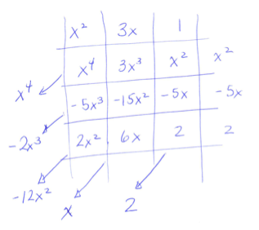
Sample student work:
$$\left(x^{2}+3x+1\right)\left(x^{2}-5x+2\right)=x^{4}-2x^{3}-12x^{2}+x+2$$

- Use the tabular method to multiply $(x^{2}+3x+1)(x^{2}-2)$ and combine like terms.
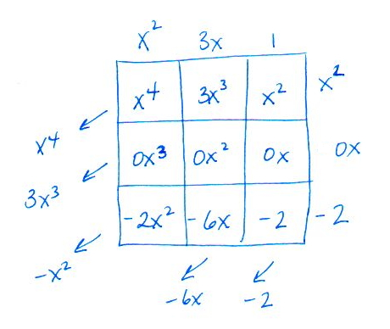
Sample student work:
Another solution method would be to omit the row for $0x$ in the table and to manually add all table entries instead of adding along the diagonals:
$$\left(x^{2}+3x+1\right)\left(x^{2}-2\right)=x^{4}+3x^{3}+x^{2}-2x^{2}-6x-2 \\ =x^{4}+3x^{3}-x^{2}-6x-2$$
$$\left(x^{2}+3x+1\right)\left(x^{2}-2\right)=x^{4}+3x^{3}-x^{2}-6x-2$$
Scaffolding:
For further scaffolding, you might ask students to see the pattern using numerical expressions, such as:
$$(2-1)(2^{1}+1)$$
$$(2-1)(2^{2}+2+1)$$
$$\left(2-1\right)\left(2^{3}+2^{2}+ 2+1\right).$$
Can they describe in words or symbols the meaning of these quantities?

Example 2 (6 minutes)
Prior to Example 2, consider asking students to find the products of each of these expressions.
$$(x-1)(x+1)$$
$$(x-1)(x^{2}+x+1)$$
$$(x-1)(x^{3}+x^{2}+x+1)$$
Students may work on this in mixed-ability groups and come to generalize the pattern.

Example 2
Multiply the polynomials $(x-1)(x^{4}+x^{3}+x^{2}+x+1)$ using a table. Generalize the pattern that emerges by writing down an identity for $(x-1)(x^{n}+x^{n-1}+…+x^{2}+x+1)$ for $n$ a positive integer.
MP.8
$$\left(x-1\right)\left(x^{4}+x^{3}+x^{2}+x+1\right)=x^{5}-1$$
$$x -1$$
$$x^{5}$$ | $$-x^{4}$$
$$x^{4}$$ | $$-x^{3}$$
$$x^{3}$$ | $$-x^{2}$$
$$x^{2}$$ | $$-x$$
$$x$$ | $$-1$$

$$x^{4}$$
$$x^{3}$$
$$x^{2}$$
$$x$$
$$1$$
$${0x}^{4}$$
$$x^{5}$$
$${0x}^{3}$$
$${0x}^{2}$$
$$0x$$
$$-1$$
The pattern suggests $\left(x-1\right)\left(x^{n}+x^{n-1}+…+x^{2}+x+1\right)=x^{n+1}-1$.

- What quadratic identity from Algebra I does the identity above generalize?
  - This generalizes $\left(x-1\right)\left(x+1\right)=x^{2}-1$, or more generally, the difference of squares formula $\left(x-y\right)\left(x+y\right)=x^{2}-y^{2}$ with $y=1$. We will explore this last identity in more detail in Exercises 2 and 3.

Exercises 3–4 (10 minutes)
Before moving on to Exercise 3, it may be helpful to scaffold the problem by asking students to multiply $(x-y)(x+y)$ and $(x-y)(x^{2}+xy+y^{2})$. Ask students to make conjectures about the form of the answer to Exercise 3.
MP.1
Exercises 3–4
- Multiply $\left(x-y\right)\left(x^{3}+x^{2}y+xy^{2}+y^{3}\right)$ using the distributive property and combine like terms. How is this calculation similar to Example 2?
Distribute the expression $x^{3}+x^{2}y+xy^{2}+y^{3}$ through $x-y$ to get
$\left(x-y\right)\left(x^{3}+x^{2}y+xy^{2}+y^{3}\right)=x^{4}+x^{3}y+x^{2}y^{2}+xy^{3}-x^{3}y-x^{2}y^{2}-xy^{3}-y^{4}=x^{4}-y^{4}$.
Substitute $1$ in for $y$ to get the identity for $n=3$ in Example 2.
This calculation is similar to Example 2 because it has the same structure. Substituting $1$ for $y$ results in the same expression as Example 2.

Exercise 3 shows why the mnemonic FOIL is not very helpful—and in this case does not make sense. By now, students should have had enough practice multiplying to no longer require such mnemonics to help them. They understand that the multiplications they are doing are really “repeated use of the distributive property,” an idea which started when they learned the multiplication algorithm in 4th grade. However, you may still need to summarize the process with a mnemonic. If this is the case, we recommend “Each-With-Each,” or EWE, which is short for the process of multiplying each term of one polynomial with each term of the a second polynomial and combining like terms.

To introduce Exercise 4, you might start with a group activity to help illuminate the generalization. For example, students could work in groups again to investigate the pattern found in expanding these expressions.
Scaffolding:
For further scaffolding, you might ask students to see the pattern using numerical expressions, such as:
$$(3^{2}+2^{2})(3^{2}-2^{2})$$
$$(3^{3}+2^{3})(3^{3}-2^{3})$$
$$\left(3^{4}+2^{4}\right)\left(3^{4}-2^{4}\right).$$
How do $13⋅5$ and $3^{4}-2^{4}$ relate to the first line? How do $35⋅19$ and $3^{6}-2^{6}$ relate to the second line? Etc.

$$(x^{2}+y^{2})(x^{2}-y^{2})$$
$$(x^{3}+y^{3})(x^{3}-y^{3})$$
$$(x^{4}+y^{4})(x^{4}-y^{4})$$
$$(x^{5}+y^{5})(x^{5}-y^{5})$$

- Multiply $\left(x^{2}-y^{2}\right)\left(x^{2}+y^{2}\right)$ using the distributive property and combine like terms. Generalize the pattern that emerges to write down an identity for $(x^{n}-y^{n})(x^{n}+y^{n})$ for positive integers $n$.
$\left(x^{2}-y^{2}\right)\left(x^{2}+y^{2}\right)=\left(x^{2}-y^{2}\right)⋅x^{2}+\left(x^{2}-y^{2}\right)⋅y^{2}=x^{4}-x^{2}y^{2}+x^{2}y^{2}-y^{4}=x^{4}-y^{4}$.
$$\left(x^{n}-y^{n}\right)\left(x^{n}+y^{n}\right)=x^{2n}-y^{2n}$$
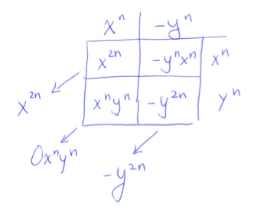
Generalization: $\left(x^{n}-y^{n}\right)\left(x^{n}+y^{n}\right)=x^{2n}-y^{2n}$.
Sample student work:

- We will use the generalized identity $x^{2n}-y^{2n}=(x^{n}-y^{n})(x^{n}+y^{n})$ several times in this module. For example, it will help us recognize that $2^{130}-1$ is not a prime number because it can be written as $(2^{65}-1)(2^{65}+1)$. Some of the problems in the Problem Set rely on this type of thinking.

Closing (4 minutes)
Ask students to share two important ideas from the day’s lesson with their neighbor. You can also use this opportunity to informally assess their understanding. Then summarize:
- Multiplying two polynomials is performed by repeatedly applying the distributive property and combining like terms.
- There are several useful identities:
- $\left(a+b\right)\left(c+d\right)=ac+ad+bc+bd$ (an example of “each-with-each”)
- ${\left(a+b\right)}^{2}=a^{2}+2ab+b^{2}$
- $\left(x^{n}-y^{n}\right)\left(x^{n}+y^{n}\right)=x^{2n}-y^{2n}$, including $\left(x-y\right)\left(x+y\right)=x^{2}-y^{2}$ and $\left(x^{2}-y^{2}\right)\left(x^{2}+y^{2}\right)=x^{4}-y^{4}$
- $\left(x-1\right)\left(x^{n}+x^{n-1}+…x^{2}+x+1\right)=x^{n+1}-1$
- (Optional) Consider a quick whiteboard activity in which students build fluency with applying these identities.
The vocabulary used in this lesson was introduced and taught in Algebra I. The definitions included in this lesson are for reference. To support students, consider creating a poster with these vocabulary words for the classroom wall.
Relevant Vocabulary
Equivalent Polynomial Expressions: Two polynomial expressions in one variable are equivalent if, whenever a number is substituted into all instances of the variable symbol in both expressions, the numerical expressions created are equal.
Polynomial Identity: A polynomial identity is a statement that two polynomial expressions are equivalent. For example, ${\left(x+3\right)}^{2}=x^{2}+6x+9$ for any real number $x$ is a polynomial identity.
Coefficient of a Monomial: The coefficient of a monomial is the value of the numerical expression found by substituting the number $1$ into all the variable symbols in the monomial. The coefficient of $3x^{2}$ is $3$, and the coefficient of the monomial $(3xyz)⋅4$ is $12$.
Terms of a Polynomial: When a polynomial is expressed as a monomial or a sum of monomials, each monomial in the sum is called a term of the polynomial.
Like Terms of a Polynomial: Two terms of a polynomial that have the same variable symbols each raised to the same power are called like terms.
Standard Form of a Polynomial in One Variable: A polynomial expression with one variable symbol, $x,$is in standard form if it is expressed as
$$a_{n}x^{n}+a_{n-1}x^{n-1}+…+a_{1}x+a_{0},$$
where $n$ is a non-negative integer, and $a_{0},a_{1},a_{2},…,a_{n}$ are constant coefficients with $a_{n}≠0$.
A polynomial expression in $x$ that is in standard form is often just called a polynomial in $x$ or a polynomial.
The degree of the polynomial in standard form is the highest degree of the terms in the polynomial, namely $n$. The term $a_{n}x^{n}$ is called the leading term and $a_{n}$ (thought of as a specific number) is called the leading coefficient. The constant term is the value of the numerical expression found by substituting $0$ into all the variable symbols of the polynomial, namely $a_{0}$.

Exit Ticket (5 minutes)
Name Date
Lesson 2: The Multiplication of Polynomials

Exit Ticket

Multiply $(x-1)(x^{3}+4x^{2}+4x-1)$ and combine like terms. Explain how you reached your answer.

Exit Ticket Sample Solutions

Multiply $(x-1)(x^{3}+4x^{2}+4x-1)$ and combine like terms. Explain how you reached your answer.
Tabular method:
$$x -1$$
$$x^{4}$$ | $$-x^{3}$$
$${4x}^{3}$$ | $$-4x^{2}$$
$${4x}^{2}$$ | $$-4x$$
$$-x$$ | $$1$$

$$x^{3}$$
$$4x^{2}$$
$$4x$$
$$-1$$
$${3x}^{3}$$
$$x^{4}$$
$${0x}^{2}$$
$$-5x$$
$$1$$
$$\left(x-1\right)\left(x^{3}+4x^{2}+4x-1\right)=x^{4}+3x^{3}-5x+1$$
Using the distributive property (Each-With-Each):
$\left(x-1\right)\left(x^{3}+4x^{2}+4x-1\right)=x^{4}+4x^{3}+4x^{2}-x-x^{3}-4x^{2}-4x+1=x^{4}+3x^{3}-5x+1$.

Problem Set Sample Solutions

- Complete the following statements by filling in the blanks.
- $\left(a+b\right)\left(c+d+e\right)=ac+ad+ae+____+____+____$ | $$bc, bd, be$$
- ${\left(r-s\right)}^{2}={\left( \underline{ }\right)}^{2}-\left(\underline{ }\right)rs+s^{2}$ | $$r, 2$$
- ${\left(2x+3y\right)}^{2}={\left(2x\right)}^{2}+2\left(2x\right)\left(3y\right)+{\left( \underline{ }\right)}^{2}$ | $$3y$$
- $\left(w-1\right)\left(1+w+w^{2}\right)= \underline{ }-1$ | $$w^{3}$$
- $a^{2}-16=(a+ \underline{ })(a- \underline{ })$ | $$4, 4$$
- $\left(2x+5y\right)\left(2x-5y\right)= \underline{ }- \underline{ }$ | $$4x^{2}, 25y^{2}$$
- $\left(2^{21}-1\right)\left(2^{21}+1\right)= \underline{ }- 1$ | $$2^{42}$$
- $\left[\left(x-y\right)-3\right][(x-y)+3] ={\left(\underline{ }\right)}^{2}- 9$ | $$x-y$$

- Use the tabular method to multiply and combine like terms.
  - $(x^{2}-4x+4)(x+3)$
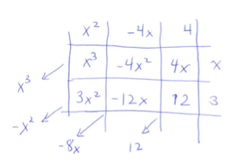
Sample student work:
$$\left(x^{2}-4x+4\right)\left(x+3\right)=x^{3}-x^{2}-8x+12$$

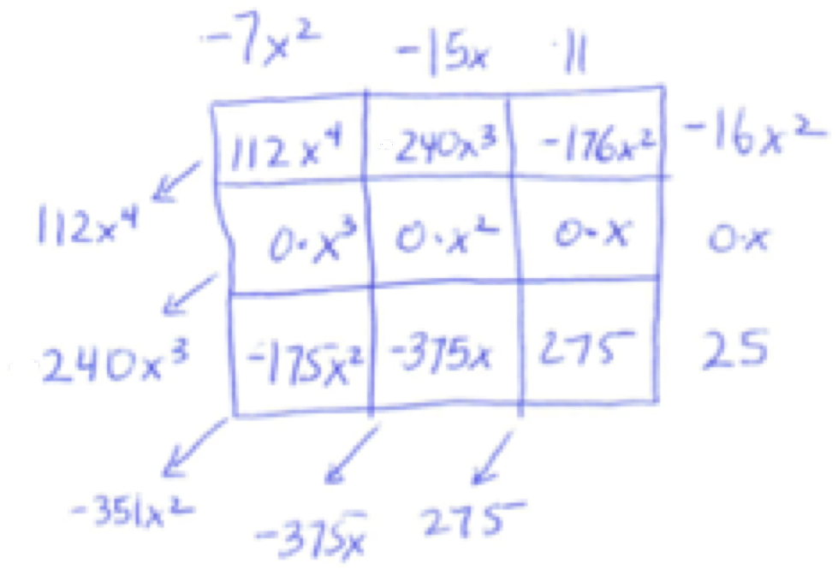
  - $\left(11-15x-7x^{2}\right)\left(25-16x^{2}\right)$
Sample student work:
$$\left(11-15x-7x^{2}\right)\left(25-16x^{2}\right)=112x^{4}+240x^{3}-351x^{2}-375x+275$$

  - $\left(3m^{3}+m^{2}-2m-5\right)\left(m^{2}-5m-6\right)$
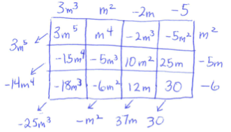
Sample student work:
$$\left(3m^{3}+m^{2}-2m-5\right)\left(m^{2}-5m-6\right)=3m^{5}-14m^{4}-25m^{3}-m^{2}+37m+30$$

  - $(x^{2}-3x+9)(x^{2}+3x+9)$
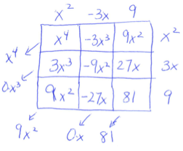
Sample student work:
$$\left(x^{2}-3x+9\right)\left(x^{2}+3x+9\right)=x^{4}+9x^{2}+81$$

- Multiply and combine like terms to write as the sum or difference of monomials.
- $2a(5+4a)$  $$8a^{2}+10a$$ | - $x^{3}\left(x+6\right)+9$  $$x^{4}+6x^{3}+9$$
- $\frac{1}{8}(96z+24z^{2})$  $$12z+3z^{2}$$ | - $2^{23}(2^{84}-2^{81})$  $$2^{107}-2^{104}$$
- $(x-4)(x+5)$  $$x^{2}+x-20$$ | - $\left(10w-1\right)\left(10w+1\right)$  $$100w^{2}-1$$
- $(3z^{2}-8)(3z^{2}+8)$  $$9z^{4}-64$$ | - $\left(-5w-3\right)w^{2}$  $$-5w^{3}-3w^{2}$$
- $8y^{1000}\left(y^{12200}+0.125y\right)$  $${8y}^{13200}+y^{1001}$$ | - $(2r+1)(2r^{2}+1)$  $$4r^{3}+2r^{2}+2r+1$$
- $(t-1)(t+1)(t^{2}+1)$  $$t^{4}-1$$ | - $(w-1)({w^{5}+w}^{4}+w^{3}+w^{2}+w+1)$  $$w^{6}-1$$
- $(x+2)(x+2)(x+2)$  $$x^{3}+6x^{2}+12x+8$$ | - $n(n+1)(n+2)$  $n^{3}+3n^{2}+2n$
- $n(n+1)(n+2)(n+3)$  $n^{4}+6n^{3}+11n^{2}+6n$ | - $n(n+1)(n+2)(n+3)(n+4)$  $$n^{5}+10n^{4}+35n^{3}+50n^{2}+24n$$
- $\left(x+1\right)(x^{3}-x^{2}+x-1)$  $$x^{4}-1$$ | - $\left(x+1\right)(x^{5}-x^{4}+x^{3}-x^{2}+x-1)$  $$x^{6}-1$$
- $(x+1)(x^{7}-x^{6}+x^{5}-x^{4}+x^{3}-x^{2}+x-1)$  $$x^{8}-1$$ | - $(m^{3}-2m+1)(m^{2}-m+2)$  $$m^{5}-m^{4}+3m^{2}-5m+2$$

- Polynomial expressions can be thought of as a generalization of place value.
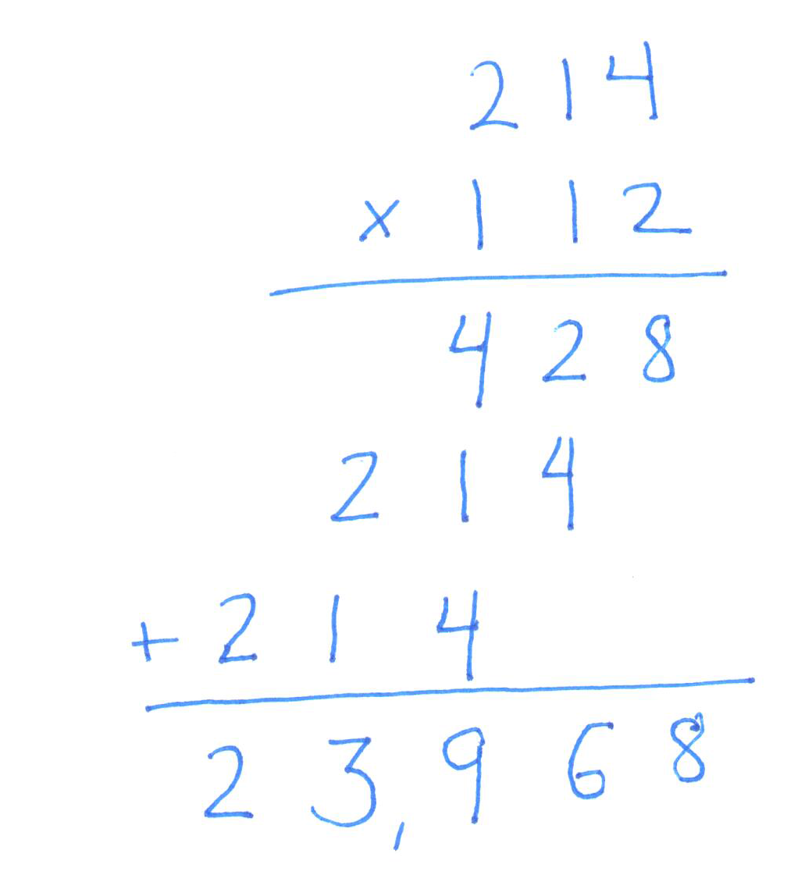
  - Multiply $214×112$ using the standard paper-and-pencil algorithm.

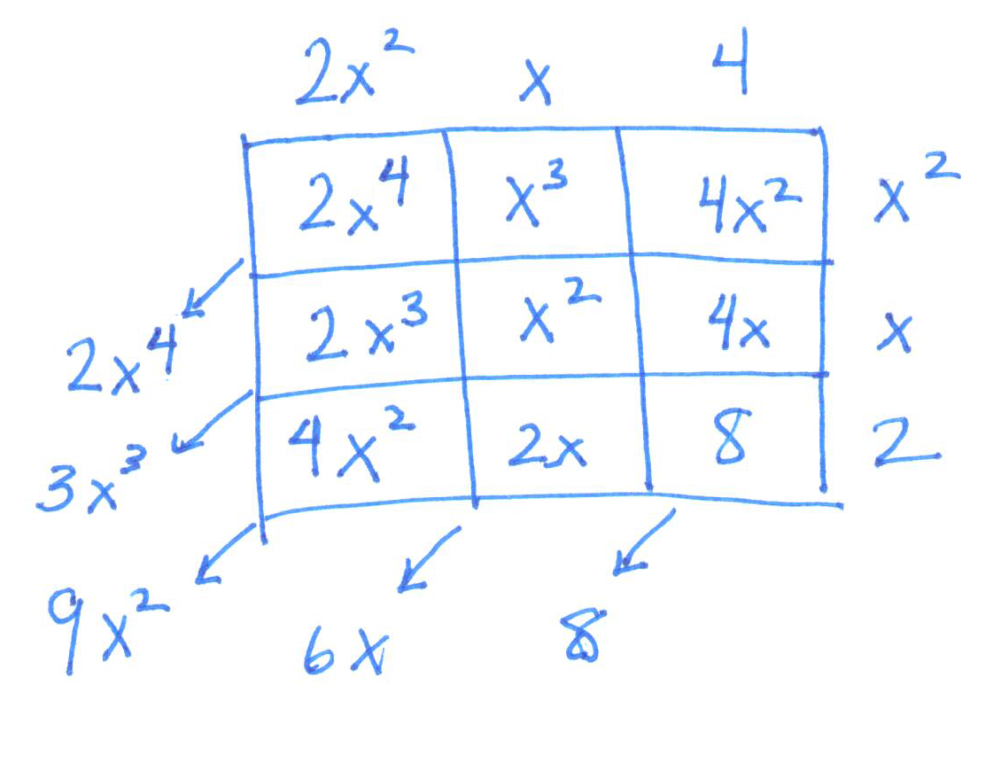
  - Multiply $(2x^{2}+x+4)(x^{2}+x+2)$ using the tabular method and combine like terms.
$$\left(2x^{2}+x+4\right)\left(x^{2}+x+2\right)=2x^{4}+3x^{3}+9x^{2}+6x+8$$
  - Put $x=10$ into your answer from part (b).
$$23,968$$

  - Is the answer to part (c) equal to the answer from part (a)? Compare the digits you computed in the algorithm to the coefficients of the entries you computed in the table. How do the place-value units of the digits compare to the powers of the variables in the entries?
Yes. The digits computed in the algorithm are the same as the coefficients computed in the table entries. The zero-degree term in the table corresponds to the ones unit, the first-degree terms in the table correspond to the tens unit, the second-degree terms in the table correspond to the hundreds unit, and so on.

- Jeremy says $\left(x-9\right)\left(x^{7}+x^{6}+x^{5}+x^{4}+x^{3}+x^{2}+x+1\right)$must equal${ x}^{7}+x^{6}+x^{5}+x^{4}+x^{3}+x^{2}+x+1$ because when $x=10$, multiplying by $x-9$ is the same as multiplying by $1$.
  - Multiply $\left(x-9\right)\left(x^{7}+x^{6}+x^{5}+x^{4}+x^{3}+x^{2}+x+1\right)$.
$$x^{8}-8x^{7}-8x^{6}-8x^{5}-8x^{4}-8x^{3}-8x^{2}-8x-9$$

  - Put $x=10$ into your answer.
$$100,000,000-80,000,000- 8,000,000-800,000-80,000-8,000- 800-80-9$$
$$100,000,000-88,888,889 = 11,111,111$$

  - Is the answer to part (b) the same as the value of $x^{7}+x^{6}+x^{5}+x^{4}+x^{3}+x^{2}+x+1$when $x=10$?
Yes.

  - Was Jeremy right?
No, just because it is true when $x$ is $10$, does not make it true for all real $x$. The two expressions are not algebraically equivalent.
$$x$$
$$y$$
- In the diagram, the side of the larger square is $x$ units and the side of the smaller square is $y$ units. The area of the shaded region is $\left(x^{2}-y^{2}\right)$ square units. Show how the shaded area might be cut and rearranged to illustrate that the area is $(x-y)(x+y)$ square units.

$$x$$
$$y$$
$$x+y$$
$$x-y$$
$$x-y$$
Solution:

