Objective: Use the properties of exponents to interpret expressions for exponential functions and to graph exponential functions.

Bellwork: Cellphone/Calculator Assignment

1. Look up your grade on studentview and determine what you need to do to improve your grade.

2. Using a calculator or desmos, find the initial mass of radium and the percentage of the initial mass present after 25 years if the quantity present after t years is given by:

Y=25(1/2)^{t/1599}

Hint: plug in t=0 to find initial mass.
Hint: plug in t=25 to find mass after 25 years.

a. initial mass = __________ grams
b. percentage of initial mass left after 25 years = ______.

Lesson: Exponential Growth and Decay

Definitions

Definition: An exponential function f with base a is denoted by

y=a^{x} where a>0, a≠1, and x is any real number.

Definition: An exponential growth function (model)
is given by the equation

y=ac^{bx}, b>0.

Definition: An exponential decay function (model)
is given by the equation

y=ac^{bx}, b<0.

If a>0, then the exponential function(whether growth or decay) is a positive exponential function.
If a<0, then the exponential function (whether growth or decay) is a negative exponential function.

A table can help here. y=ac^{bx} c is the base

c>1 | c>1 | c<1 | c<1
a>0, b>0 positive exp growth fn. | a>0,b<0  positive exp decay fn. | a>0, b>0  positive exp  decay fn. | a>0, b<0  positive exp  growth fn.
a<0, b>0  negative exp  growth fn. | a<0, b<0  negative exp decay fn. | a<0, b>0  negative exp decay fn. | a<0, b<0  negative exp growth fn.

Example 1: Label exponential growth or decay

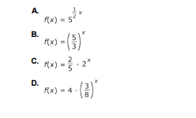
a. exponential growth 5>1 ½>0
b. exponential growth 5/3>1
c. exponential growth 2>1
d. exponential decay (3/8)<1

Example 2: Percent Change

y=ac^{bx} c is the base

a. f(x)=4(5)^{x} c=5 b=1 a=4.

Step 1: Make Table and fill in
x | f(x) | % change
0 | 4 | ---
1 | 20 | (20-4)/4 * 100 | 400 %
2 | 100 | (100-20)/20 | 400 %
Step 2: Answer=400%

You can get this from the function through (5-1)*100%.

b. f(x)=4(1.05)^{x}
x | f(x) | % change
0 | 4 | ---
1 | 4.2 | (4.2-4)/4 * 100 | 5 %
2 | 4.41 | (4.41-4.2)/4.2*100 | 5 %

You can read growth rate off the function. 5%

c. f(x)=4(.95)^{x}

x | f(x) | % change
0 | 4 | ---
1 | 3.8 | (3.8-4)/4 * 100 | -5 %
2 | 3.61 | (3.61-3.8)/3.8*100 | -5 %
You can read the decay rate off the function. 5%

d. f(x)=4(.05)^{x}
x | f(x) | % change
0 | 4 | ---
1 | .2 | (.2-4)/4 * 100 | -95 %
2 | .01 | (3.61-3.8)/3.8*100 | -95 %

You can read the decay rate off the function: The decay rate is 95%

Example 3 Type of exponential function: positive growth, negative growth, positive decay, negative decay.

f(x)=-6(2/5)^{x} negative exponential decay function

x | f(x)
0 | -6
1 | -12/5
2 | -24/25

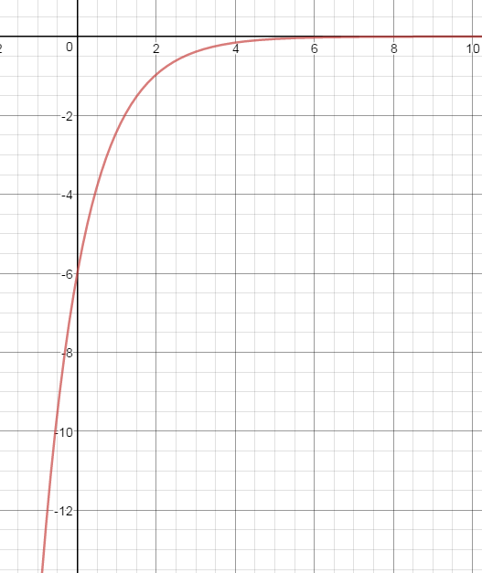

f(x)=-4/5(2)^{x}: negative exponential growth function

x | f(x)
0 | -4/5
1 | -8/5
2 | -16/5
3 | -32/5

f(x)=5(1/2)^{x}: positive exponential decay.

x | f(x)
0 | 5
1 | 5/2
2 | 5/4

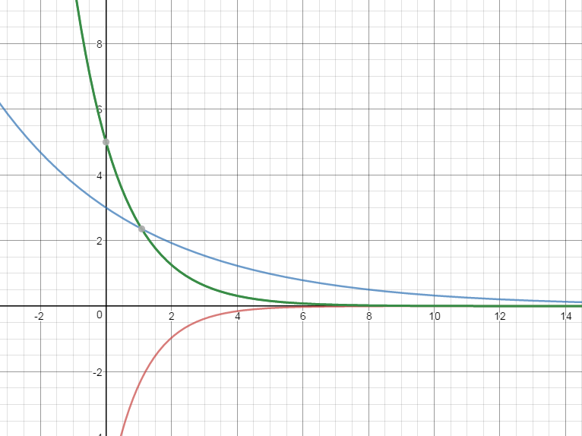

Practice (Guided): Identify the decay/growth rate

1. f(x)=6(1.06)^{x}

2. f(x)=1000(6)^{x}

3. f(x)=10,000(.94)^{x}

4. f(x)=35(.06)^{x}

5. f(x)=300(.97)^{x}

6. f(x)=2500(3)^{x}

7. f(x)=1500(.03)^{x}

8. f(x)=975(1.03)^{x}

Closure: Quiz

Select the functions that have a growth rate of 5.2% by putting a check in the appropriate box.

 | yes | no
f(x)=200(1.052)^{x}
f(x)=500(1.52)^{x}
f(x)=900(1+.052)^{x}
f(x)=800(.052)^{x}
f(x)=700(5.2)^{x}
f(x)=400(1+.52)^{x}

Homework: Complete the following questions.
Name Period

1. The half life of a radioactive material is the amount of time it takes half of the material to decay so that half of the original material remaining. The half life of vanadium-48 is represented by the equation

A=A₀(2)^{-.0626t}

A₀ is the initial amount and t is time in days.

After 16 days is more or less than ½ of the initial amount of vanadium-48 remaining? Show your work.
2. The population of a city is modeled by the equation
P=1.5(1.25)^{.25t}. Answer the following true/false questions by putting a check in the appropriate box.

Statement | True | False
Population grows exponentially
Current population is 1.5 m
The population grows by 25% every 25 years

