College Algebra
Objective: Use the properties of exponents to
interpret expressions for exponential functions.
Bellwork: Write the following definition in your
notebook:
The exponential function f with base a is denoted by
f(x)=a^{x} where a>0, , x is any real number.
Calculator Assignment: Solve the following problems on your calculator.

1. f(x) = 2^{x}, x= -3.1 f(-3.1)=
2. f(x)= 2^{-x}, x= Pi f(Pi)=
(Two raised to minus x)
3. f(x)= 6^{x}, x=3/2 f(3/2)=

Lesson: Properties of Exponents
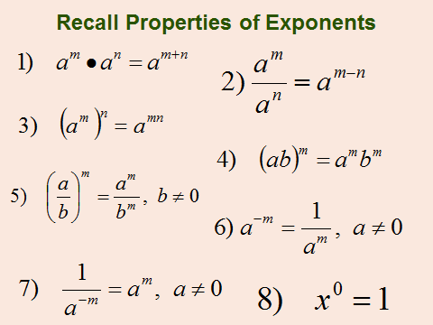

9)|a²|=a² 10) –a²=-a*a 11) (-a)²=-a*-a=a²

Practice:

1. 3²*3⁴=3⁶=729 2. 3⁷/3⁴=3³=27

3. 2⁻⁴=1/(2⁴)=1/16. 4. (2²+1)⁰=1

5. (5x)³=5³x³=125x³. 6. (y³)⁻⁴=y⁻¹²
Distribute the 3
7. (2/x)³= 2³/x³=8/x³ 8. |(-2)²|=4
Distribute the 3

9. -2²=-4. 10. (-2)²=4

Exponential Quiz Name Period

1. (-5)²=
2. -5²=
3. 2*2⁴=
4. 4/4⁶=

Evaluate/Simplify

1. 5x⁻² @ x=3 5(3)⁻²=5/9 minus means 1/
2. (1/3)(-x)³=(1/3)(-3)³=-9. (-3)³=-3*-3*-3
3. (-3ab⁴)(4ab⁻³)=(-12a²b) simplify like terms
4. (2xy²)³=8x³y⁶ distribute the 3
5. 3a(-4a²)⁰= anything to the zero is one
6. (5x³/y)²=25x⁶/y² distribute the 2.

Practice: Rewrite with Positive Exponents
Negative Exponent means 1/ or it can mean flip

1. x⁻¹=1/x
2. 1/(3x⁻²)=(1/3)x²=x²/3
3. (12a³b⁻⁴)/(4a⁻²)b=3a⁵/b⁵
4. (3x²/y)⁻²= (y/3x²)²=y²/9x⁴

Practice: Complete rules for exponents and turn in.
Homework: Book page A24 12-38 even.

Closure: Look at the rules and write again those you
can’t remember. Read and Take Notes on Section 3.1.

